Lab No. 05

Inheritance in C++

(Single, Multilevel)

Lab Objectives | Following are the lab objectives:  - Understand the concept of inheritance in Object-Oriented Programming.  - Learn how to create base and derived classes in C++.  - Implement single and multilevel inheritance in programs.  - Apply inheritance to promote code reusability and better program structure.

Student ID | 10011 | Student Name |  | Sajjal Tariq
 | Marks |  | Obtained Marks |  | Comments
Task 1 | 15
Task 2 | 15
Task 3 | 15
Total Marks | 45
 | Lab Instructor

Inheritance in C++
The capability of a class to derive properties and characteristics from another class is called Inheritance. Inheritance is one of the most important features of Object-Oriented Programming in C++. In this article, we will learn about inheritance in C++, its modes and types along with the information about how it affects different properties of the class.

Syntax
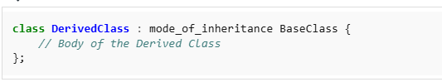
where mode of inheritance controls the access level of the inherited members of the base class in the derived class. In C++, there are 3 modes of inheritance:
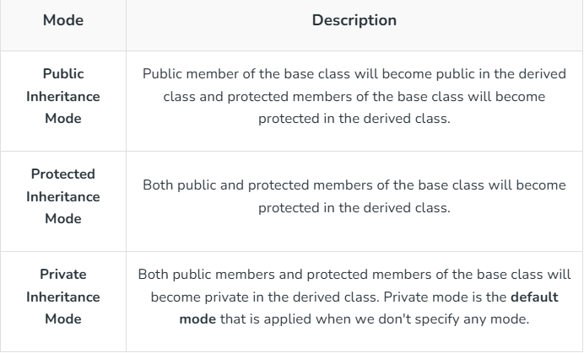
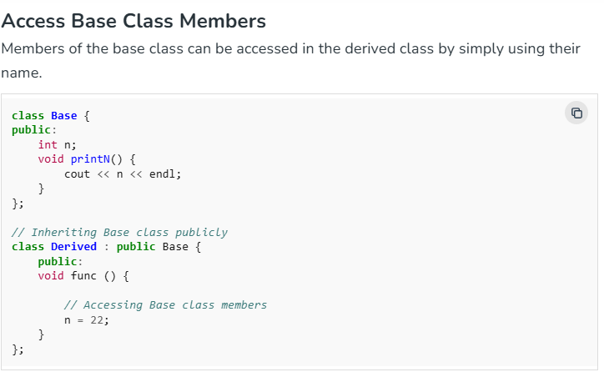
The public members of the Base class can be accessed through the objects of the Derived class if the Base class is inherited publicly as in the above example.
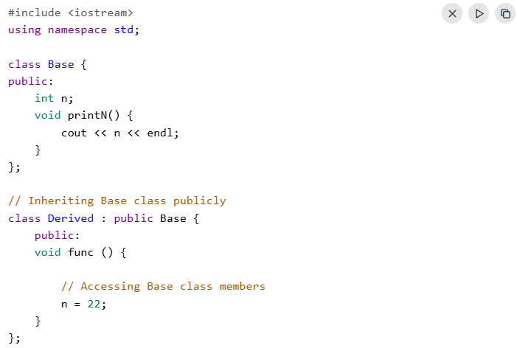
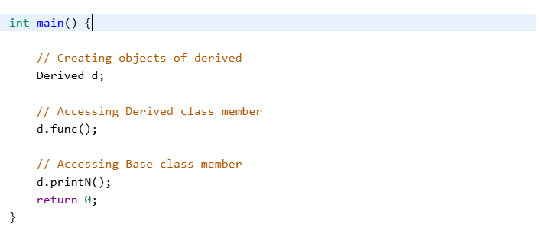
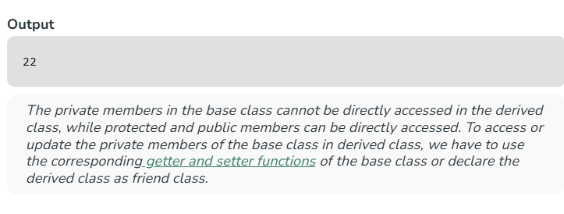

Types Of Inheritance in C++
The inheritance can be classified on the basis of the relationship between the derived class and the base class. In C++, we have 5 types of inheritances:
- Single inheritance
- Multilevel inheritance
- Multiple inheritance
- Hierarchical inheritance
- Hybrid inheritance

1. Single Inheritance
In single inheritance, a class is allowed to inherit from only one class. i.e. one base class is inherited by one derived class only.
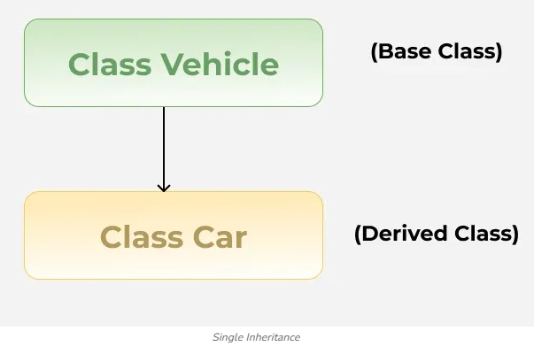
Example:
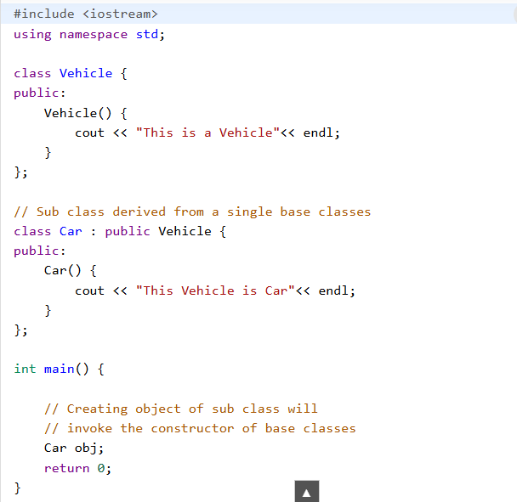
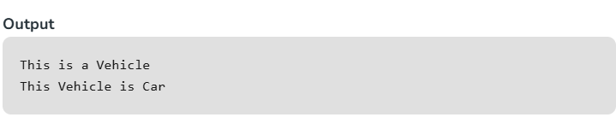

3. Multilevel Inheritance
In multilevel inheritance, a derived class is created from another derived class and that derived class can be derived from a base class or any other derived class. There can be any number of levels. For example, a vehicle can be a four-wheeler, and a four-wheeler vehicle can be a car.
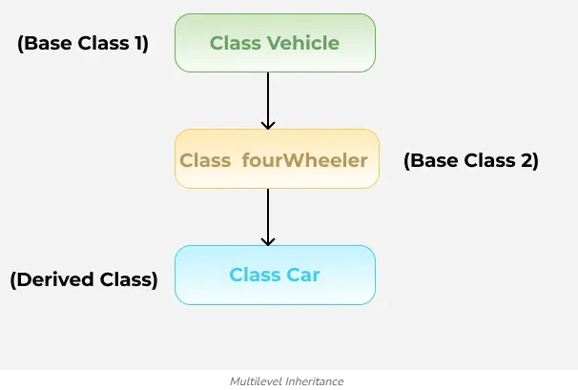
Example:
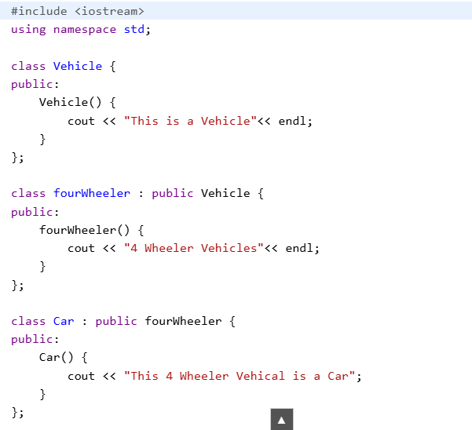
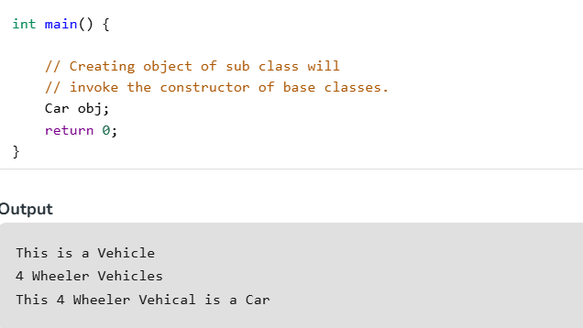

Lab Tasks
Task 1: Cylinder Inherits Circle (15 marks)
See the following class diagram of circle & cylinder and implement inheritance relationship of classes in python.
You need to implement following items for each class;
- Constructors
- Setters
- Getters
- Member Methods

Code:
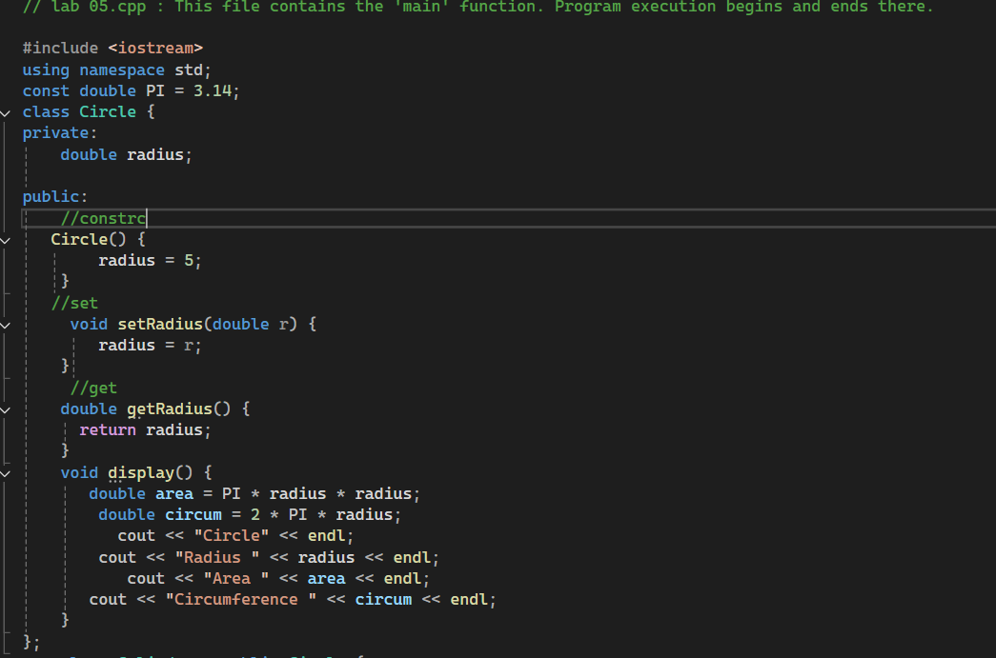


Output:
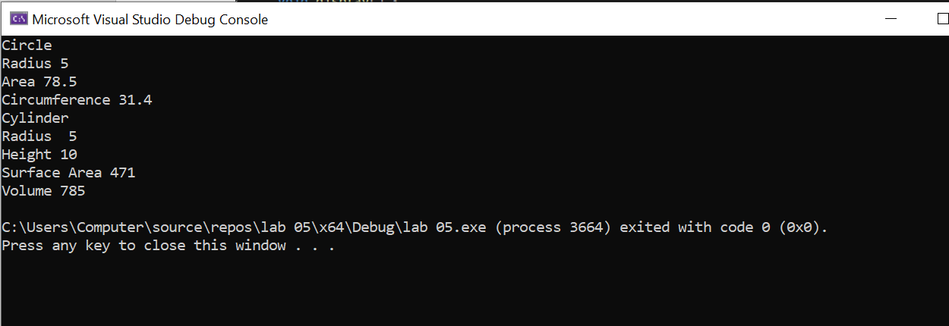

Task2 : Point & Point3D (15 marks)
See the following class diagram of point & point3d and implement inheritance relationship of classes in python.
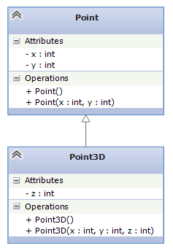

Code:
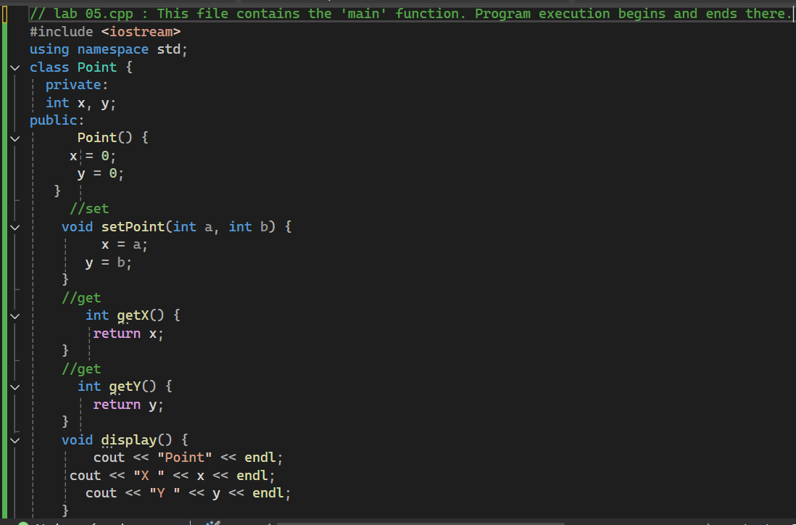
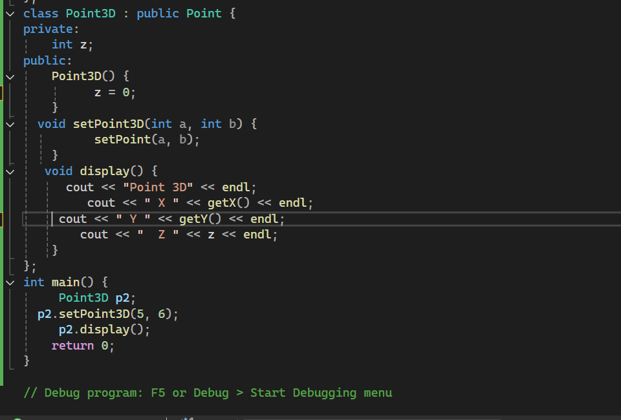
Output:
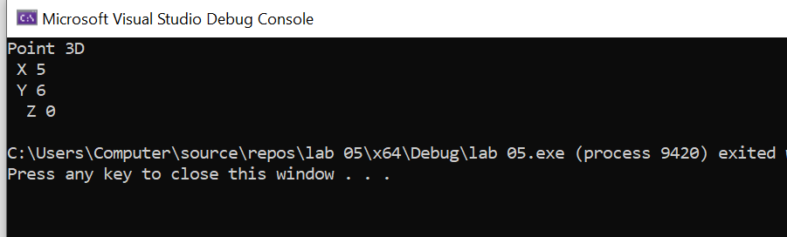
Task 3: Multi-level Inheritance (15 marks)
See the following class diagram and implement multi-level inheritance relationship of classes in C++.
You need to implement following items for each class;
- Constructors
- Setters
- Getters
- Member Methods
Demonstrate working of your classes.
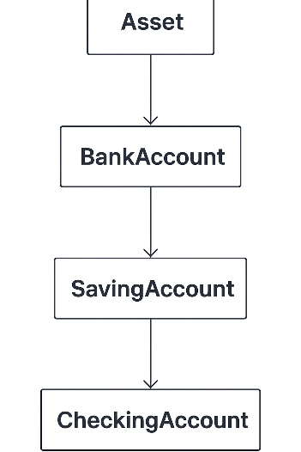

(Past your code here.)

Code:



Output:


